Versions, Versioning, and Versionality
31 October 2015
Information Commons, 4th Floor
Loyola University Chicago

This day-conference is about versions as things, versions as implemented editorially or in performance or for particular audiences (versioning), and leads on to theoretical reflection upon the condition of versionality.

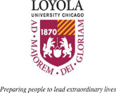

Saturday, October 31, 2015

8:30 a.m. Continental Breakfast

9:00 – 10:30 a.m. Session 1

Keynote Lecture Michael Anesko
Penn State University
The Textual Condition of Henry James’s
The Ambassadors: A Revised Scenario

Round Table Peter Shillingsburg
Casey Jergenson
Grace Stevens
Brett Beasley

10:30 – 10:45 Break

10:45 – 12: 30 Session 2

Keynote Lecture Robin Schulze
University of Delaware
When is a Version Not a Version?
Printing Marianne Moore”

Round Table Jack Kerkering
Naomi Gades
Lyle Enright
Rick Gilbert

12:30 – 2:00 Lunch

Saturday, October 31, 2015

2:00 – 3:30 Session 3

Keynote Lecture Joseph Janangelo
Loyola University Chicago
Serving the Material: Remastering Maria Callas and Completing Judy Garland

Round Table Tim Munro
Will Farina
Wesley Peart

3:30 – 3:45 Break

3:45 – 5:15 Session 4

Keynote Lecture Suzanne Gossett
Loyola University Chicago
What Do We Mean by “Versions” of Shakespeare’s Plays

Round Table John Gouws
Jim Knapp
Anna Cooperrider
Lydia Craig

5:15 – 6:15 Reception

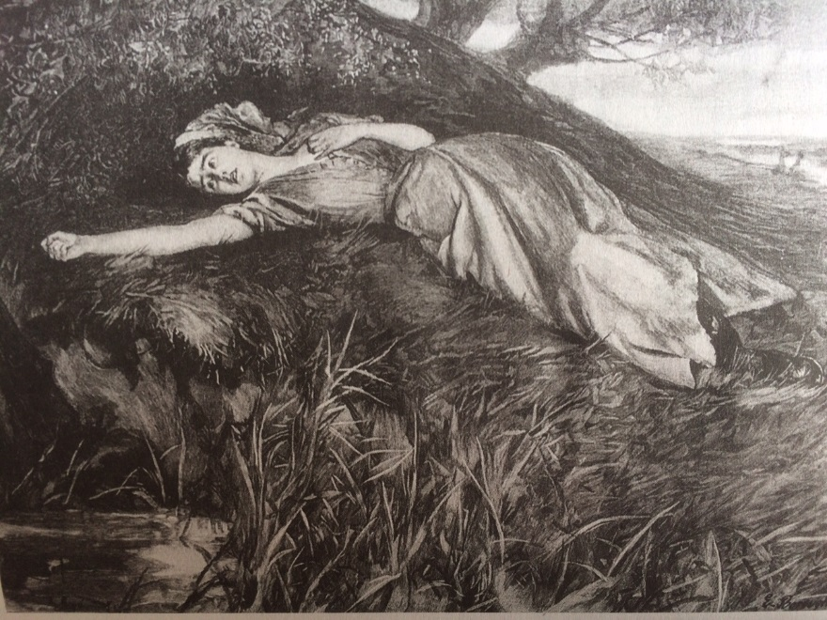
Have we become more interested in versions of cultural works than in works themselves? Versioning seems to be gathering allegiance amongst scholarly editors and university presses that publish “complete works” series. The traditional ideal of the reading text of a work established editorially on the basis of final authorial intention has less purchase than it once had. Historical appeals to textual authenticity as witnessed by a manuscript or printed form are in the ascendant, and digital archives have strengthened the shift by routinely aiming to capture in their complex encodings the text and physical features of the historical document. Similarly, heightened interest in historical performances of dramatic works and the remastering of music recorded live or in the studio have brought added attention to the question of versionality.
“Tess flung herself down upon the undergrowth of rustling spear-grass as upon a bed.”

